Design Patterns

Singleton:

Motivation
In many cases it's important to have only one instance for a class. For example, in a system there should be only one file system or only a print spooler. Usually singletons are used for centralized management of internal or external resources and they provide a global point of access to themselves.
The same instance can be used from everywhere, being impossible to invoke directly the constructor each time.

Intent
Ensure that only one instance of a class is created.
Provide a global point of access to the object.

Applicability & Examples
According to the definition the singleton pattern should be used when there must be exactly one instance of a class, and when it must be accessible to clients from a global access point. Here are some real situations where singleton is used:

Example 1 - Configuration Classes
The Singleton pattern is used to design the classes which provides the configuration settings for an application. By implementing configuration classes as Singleton not only that we provide a global access point, but we also keep the instance we use as a cache object. When the class is instantiated( or when a value is read ) the singleton will keep the values in its internal structure. If the values are read from the database or from files this avoids the reloading the values each time the configuration parameters are used.

Example 2 - Accesing resources in shared mode
It can be used in the design of an application that needs to work with the serial port. Let's say that there are many classes in the application, working in an multi-threading environment, which needs to operate actions on the serial port. In this case a singleton with synchronized methods could be used to be used to manage all the operations on the serial port.

Example 3 - Factories implemented as Singletons
Let's assume that we design an application with a factory to generate new objects(Account, Customer, Site, Address objects) with their ids, in an multithreading environment. If the factory is instantiated twice in 2 different threads then is possible to have 2 overlapping ids for 2 different objects. If we implement the Factory as a singleton we avoid this problem. Combining Abstract Factory or Factory Method and Singleton design patterns is a common practice.

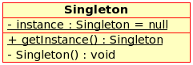

Iterator

Motivation
One of the most common data structures in software development is what is generic called a collection. A collection is just a grouping of some objects. They can have the same type or they can be all cast to a base type like object. A collection can be a list, an array, a tree and the examples can continue.
But what is more important is that a collection should provide a way to access its elements without exposing its internal structure. We should have a mechanism to traverse in the same way a list or an array. It doesn't matter how they are internally represented.
The idea of the iterator pattern is to take the responsibility of accessing and passing through the objects of the collection and put it in the iterator object. The iterator object will maintain the state of the iteration, keeping track of the current item and having a way of identifying what elements are next to be iterated.

Intent
Provide a way to access the elements of an aggregate object sequentially without exposing its underlying representation.
The abstraction provided by the iterator pattern allows you to modify the collection implementation without making any changes outside of collection.

Applicability & Examples
The iterator pattern allow us to:
- access contents of a collection without exposing its internal structure.
- support multiple simultaneous traversals of a collection.
- provide a uniform interface for traversing different collection.
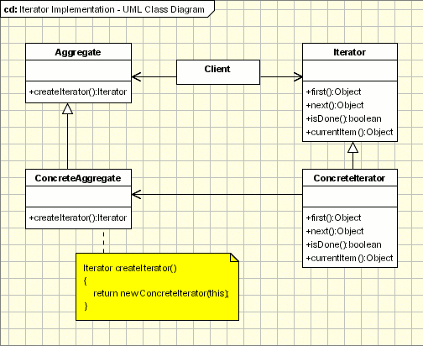

Façade

Motivation
Facade discusses encapsulating a complex subsystem within a single interface object. This reduces the learning curve necessary to successfully leverage the subsystem. It also promotes decoupling the subsystem from its potentially many clients. On the other hand, if the Facade is the only access point for the subsystem, it will limit the features and flexibility that “power users” may need.

Intent

Provide a unified interface to a set of interfaces in a subsystem. Façade defines a higher-level interface that makes the subsystem easier to use.

Wrap a complicated subsystem with a simpler interface.

Comparison with other design patterns

Facade defines a new interface, whereas Adapter uses an old interface. Remember that Adapter makes two existing interfaces work together as opposed to defining an entirely new one.
Whereas Flyweight shows how to make lots of little objects, Facade shows how to make a single object represent an entire subsystem.
Mediator is similar to Facade in that it abstracts functionality of existing classes. Mediator abstracts/centralizes arbitrary communications between colleague objects. It routinely “adds value”, and it is known/referenced by the colleague objects. In contrast, Facade defines a simpler interface to a subsystem, it doesn’t add new functionality, and it is not known by the subsystem classes.
Abstract Factory can be used as an alternative to Facade to hide platform-specific classes.
Facade objects are often Singletons because only one Facade object is required.
Adapter and Facade are both wrappers; but they are different kinds of wrappers. The intent of Facade is to produce a simpler interface, and the intent of Adapter is to design to an existing interface. While Facade routinely wraps multiple objects and Adapter wraps a single object; Facade could front-end a single complex object and Adapter could wrap several legacy objects.

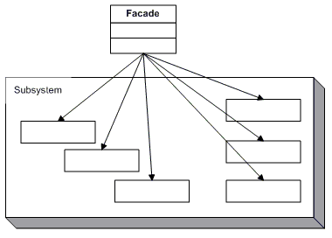
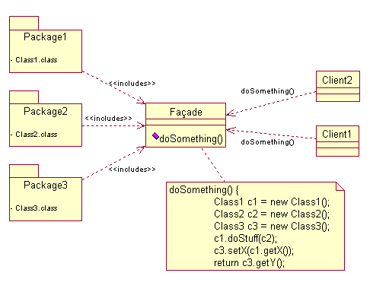

Applicability & Examples
The Facade defines a unified, higher level interface to a subsystem that makes it easier to use. Consumers encounter a Facade when ordering from a catalog. The consumer calls one number and speaks with a customer service representative. The customer service representative acts as a Facade, providing an interface to the order fulfillment department, the billing department, and the shipping department.
Operating systems are one such example - you don't see all the inner workings of your computer, but the OS provides a simplified interface to use the machine.

